INVERTING AND NON INVERTING AMPLIFIER

1. Inverting Amplifier

Aim:-
To design an inverting amplifier using an op-amp for the given gain of −2.

Apparatus Required:-
S.No | Components | Specification
1 | Operational Amplifier | IC 741
2 | Resistors | 1 kΩ, 2 kΩ
3 | Breadboard/Trainer Kit | 1
4 | CRO (Cathode Ray Oscilloscope) | 1
5 | Function Generator | 1
6 | Connecting Wires | As required
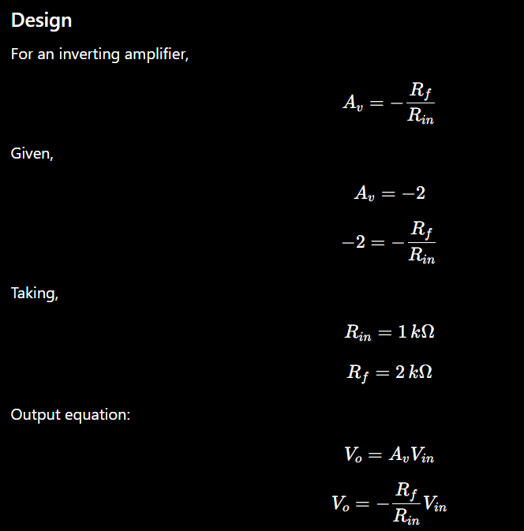

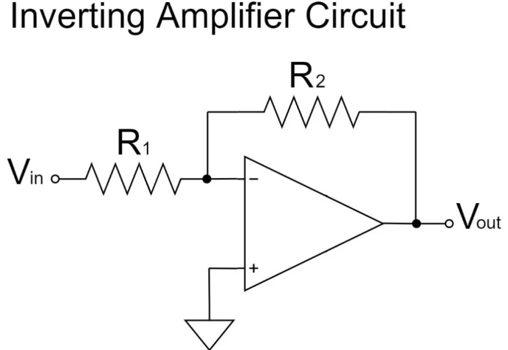

Procedure :

- Connect IC 741 on the trainer kit.
- Give dual power supply (+Vcc and −Vcc) to the IC.
- Make the circuit connections as per the circuit diagram.
- Apply sinusoidal input signal from the function generator to the inverting terminal.
- Ground the non-inverting terminal.
- Connect feedback resistor (R_f) between output and inverting terminal.
- Switch ON the power supply and CRO.
- Observe input and output waveforms on the CRO.
- Verify that the output waveform is amplified and 180° out of phase with the input.Tabulate the readings.

Observation Table:

S.No | Vin (V) | Vout (V) | Practical Gain | Theoretical Gain
1. | 0.5V | 1.38V | 3.76 | 2.2
2. | 1V | 2.94V | 3.94 | 2.2
3. | 1.5V | 4.73V | 4.153 | 2.2
4. | 2V | 6.26V | 4.13 | 2.2
5. | 2.5V | 7.96V | 4.18 | 2.2
6. | 3V | 9.50V | 4.16 | 2.2
7. | 3.6V | 10.57V | 3.396 | 2.2

Result:
The working of the inverting amplifier was studied and verified successfully.

2. Non-Inverting Amplifier

Aim
To design a non-inverting amplifier using an op-amp for the given gain of 2.

Apparatus Required
S.No | Components | Specification
1 | Operational Amplifier | IC 741
2 | Resistors | 1 kΩ, 2 kΩ
3 | Function Generator | 1
4 | CRO | 1
5 | Dual Power Supply | ±12 V
6 | Trainer Kit | 1
7 | Connecting Wires | As required

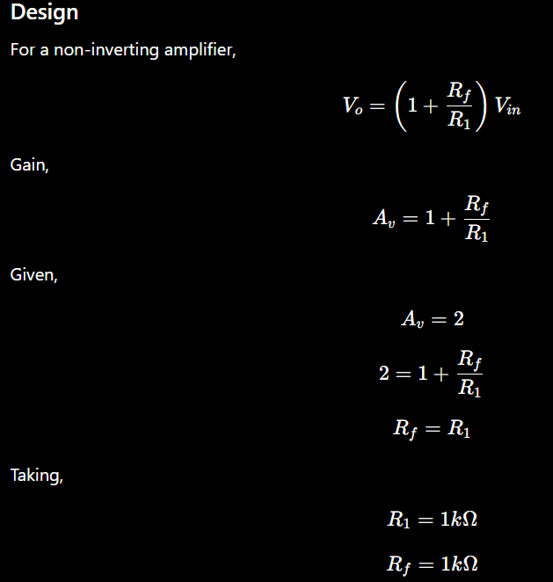

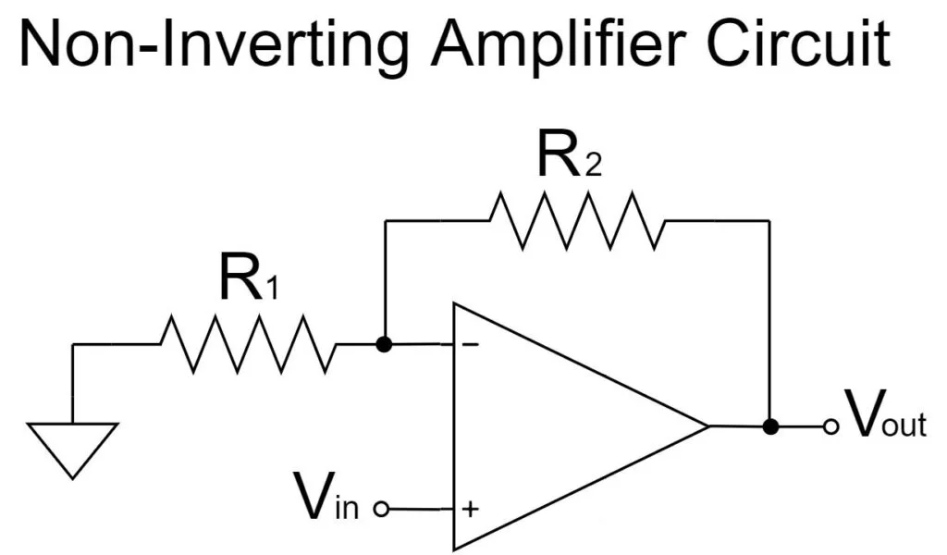

Procedure

- Place IC 741 on the trainer kit.
- Connect dual power supply ±12 V to the IC.
- Make connections as per the circuit diagram.
- Apply sinusoidal input signal from the function generator to the non-inverting terminal.
- Connect feedback resistor (R_f) and resistor (R_1) properly.
- Switch ON the power supply and CRO.
- Observe input and output waveforms on the CRO.
- Measure input voltage, output voltage, time period and frequency.
- Verify that the output waveform is amplified and in phase with the input waveform.Tabulate the readings.

Observation Table:
S.No | Vin (V) | Vout (V) | Practical Gain | Theoretical Gain
1. | 1 | -2.6 | -2.6 | -2.2
2. | 2 | -5 | -2.5 | -2.2
3. | 3 | -7.2 | -2.4 | -2.2
4. | 4 | -9.4 | -2.35 | -2.2

Result
The non-inverting amplifier was designed and verified successfully.

